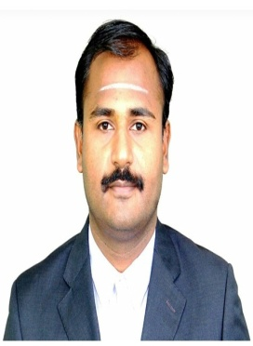
Dr.K.SenthilKannan B.Sc., M.Sc., M.Phil., SLET., Ph.D., D.Litt., and got Goldmedal in M.Sc Degree. He has also completed M.B.A., PGDCA., B.Ed., C.I., M.A., D.C.A., and D.C.H. He is having 19+ years of experience in Teaching and 10+ years of research experience. He has published 103 papers in International Journals, 1 paper in National Journal and communicated 25+ papers in International / National Journals. He has presented 152+ papers in National and International level Conferences, Seminars... during his academic career. He has completed his Ph.D degree with Highly Commended recommendation. He has presented more than twenty five papers as an ‘Invited talk’. He acted as a resource person for student’s projects. He got the Best Paper awards in Conferences. He has published 10 books in his academic career. He has guided more than 100+ Students Projects in his academic extent and also he has given more than 10000 academic lectures in physical sciences. He is the Life time member for many associations. He is the Journal Reviewer/Editorial Member for 34+ Journals of International repute. He is the visiting Faculty at many Engineering Colleges. He has organised 16 National & International events. He has guided 62 M.Sc and 10 M.Phil Scholars and guiding Research scholars. He got funding from Institutions and Industries the sum of Rs.20 Lakhs for the purpose of R&D, Presently he is the Professor, Dean/Director Research & Vice-Principal & Research Scientist at Edayathangudy G S Pillay Arts and Science College Nagapattinam TN India 611002. He Visited many countries for job as well as for Conferences. He received BEST DEAN R&D, BEST VICE PRINCIPAL, BEST INDIAN EDUCATIONIST, BEST ACADEMICAIAN AWARDs and also Global SCIENTIST AWARD from Malaysia.

