
CURRICULUM VITAE

Personal Information
Full Name | Ghaidaa Raheem Lateef Al-Awsi | 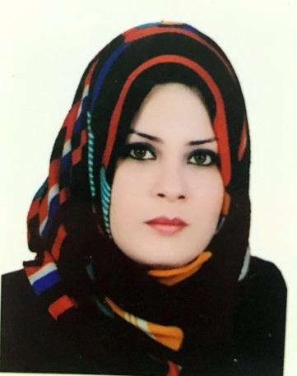
Birth Date | 1985
Place of Birth | Diwaniyah, Iraq
Gender | Female
Marital Status | Married
Nationality | Iraqi
Languages | Arabic and English
Mobile Tel. | 07830994180 - 07711788884
E-mail | Dr.Ghaidaa.R@mustaqbal-college.edu.iq

Educational Qualifications
From  Month / Year | To  Month / Year | Degree | Specification | Name & Address of Institution | Project/Thesis Title
October/2003 | July/2007 | B.Sc. | Biology | Department of Biology, University of Al-Qadisiyah | An epidemiological study of Pseudomonas sp in the burns hall - Diwaniyah Teaching Hospital
November/2009 | December/2012 | M.Sc. | Biology/ Microbiology | Department of Biology, University of Al-Qadisiyah | Isolation and Identification of Microbiological associated with infection hospitals in the city of Al-Diwaniyah
November/2014 | December/2017 | Ph.D. | Biology/ Microbiology | Department of Biology, University of Babylon | Molecular and immunological study of H. pylori bacteria in pregnant women with severe ovaries

Employments
From  Month / Year | To  Month / Year | Name & Address of Employer | Position / Department | Duties
June/2008 | December/2009 | College of Medicine/University of Al-Qadisiyah | Assist lab | Assist Lab of Microbiology
December/ 2017 | Till date | Al-Mustaqbal University College, Babylon, Iraq | Lecturer, Bio Medicine Engineering | Lecturer

Awards and Acknowledgment
Seq. | Type | Title of Project | Event | Organizer | Year
1 | Certificate of Participation | Transformative Learning Promoting Understanding Level | International Workshop | Unit of Environment Researches & Preventing of Pollution in Cooperation with University of Central Oklahoma/ U.S.A | 2017
2 | Certificate of Participation | Isolation and Diagnosis of H. Pylori in pregnant women in Al-Diwaniyah Hospital | First International Scientific Conference | College of Science-University of Al-Qadisiyah in Cooperation with University of Central Oklahoma/U.S.A | 2017
3 | Acknowledgment | Participant and Lecturer | Fifth Scientific Symposium | College of Science / University of Babylon | 2017
4 | Acknowledgment | Lab assistance | Maintenance of Biology lab | College of Medicine/University of Al-Qadisiyah | 2008
5 | Certificate of Participation | How to mummify and save animals | Workshop | Unit of Environment Researches & Preventing of Pollution/ University of Al-Qadisiyah | 2017

عضوية الجمعيات والنقابات
Seq. | Grade | Organization |  | Year
1 | Member | Iraqi Independent Society for Human Rights |  | 2009
2 | Member | Iraqi Organization for Conservation of Nature |  | 2015
3 | Member | Iraqi Syndicate of Biology |  | 2016
4 | Member | Green Oasis Organization |  | 2016
5 | Member | Together to protect Human and Environment |  | 2016
6 | Member | Iraqi Women Org. |  | 2017
7 | Member | Microbiology Society |  | 2018
8 | Member | Canadian Society of Microbiology |  | 2018
9 | Member | American Society of Microbiology |  | 2018
Training Course
Seq. | Type | Organization | Year
1 | Training Course | United Nation of Environment Program  ( UNEP) | 2015
2 | Training Course | Personal hygiene workshop, UNECEF | 2015
3 | Training Course | Social media and blogging workshop, Mercy corps. | 2015
4 | Training Course | Disease prevention workshop for rural women | 2016

Publication:
- Detection of H. pylori in Pregnant Women by Stool Culture Method.
- Relationship between H. pylori infection and IL-1β polymorphism in pregnant women.
- Isolation and diagnosis of bacteria in the hospitals of Diwaniyah city and showing the control mechanisms using antibiotics and disinfectants.
- Expression of CDKN2A (p16/Ink4a) among Colorectal Cancer Patients: A cohort study
- Immunological and Molecular Study on Helicobacter Pylori in Pregnant Woman
- Isolation and Identification of microbiological from Al-Diwanyah hospitals and Controlled by Antiseptic and Antibiotic.

